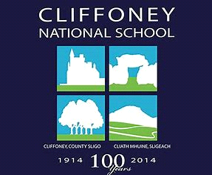

CLIFFONEY NATIONAL SCHOOL
ANNUAL ADMISSION NOTICE in respect of admissions to the 2022/2023 school year.

Admission Policy and Application Form
A copy of the school’s Admission Policy and the Application Form for Admission for the 2022/2023 is available as follows: –
To download at: www.cliffoneyns.ie
On request: By emailing cliffoneyns@gmail.com or writing to: Principal of Cliffoney N.S., Cliffoney, Co. Sligo

PART 1 - Admissions to the 2022/2023 school year

Application and Decision Dates for admission to Cliffoney N.S.
The following are the dates applicable for admission to Junior Infants

The school will commence accepting applications for admission on
October 3rd
The school shall cease accepting applications for admission on
30th of June or if there are still available places in the school, applications can be accepted over summer months and during the school year.
The date by which applicants will be notified of the decision on their application is
3 weeks or less from the date of the application submission
The period within which applicants must confirm acceptance of an offer of admission is
One week from the date an offer has been made
*Failure to accept an offer within the prescribed period above may result in the offer being withdrawn

Note: the school will consider and issue decisions on late applications in accordance with the school’s admission policy.
Number of places being made available in 2022/2023 school year
The number of places being made available in Junior Infants is 14 school places

